**Team ID:** **PNT2022TMID31030**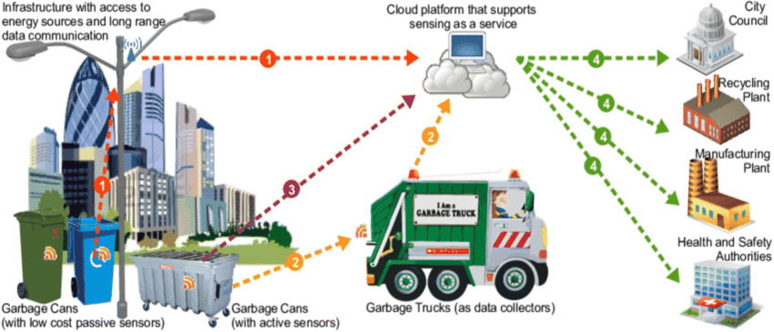

**Smart waste management for meteropolitian cities**

**TECHNOLOGY ARCHITECTURE**